Grid Hosting Capacity Document contextual model

Overview of the model

!# shows the model.
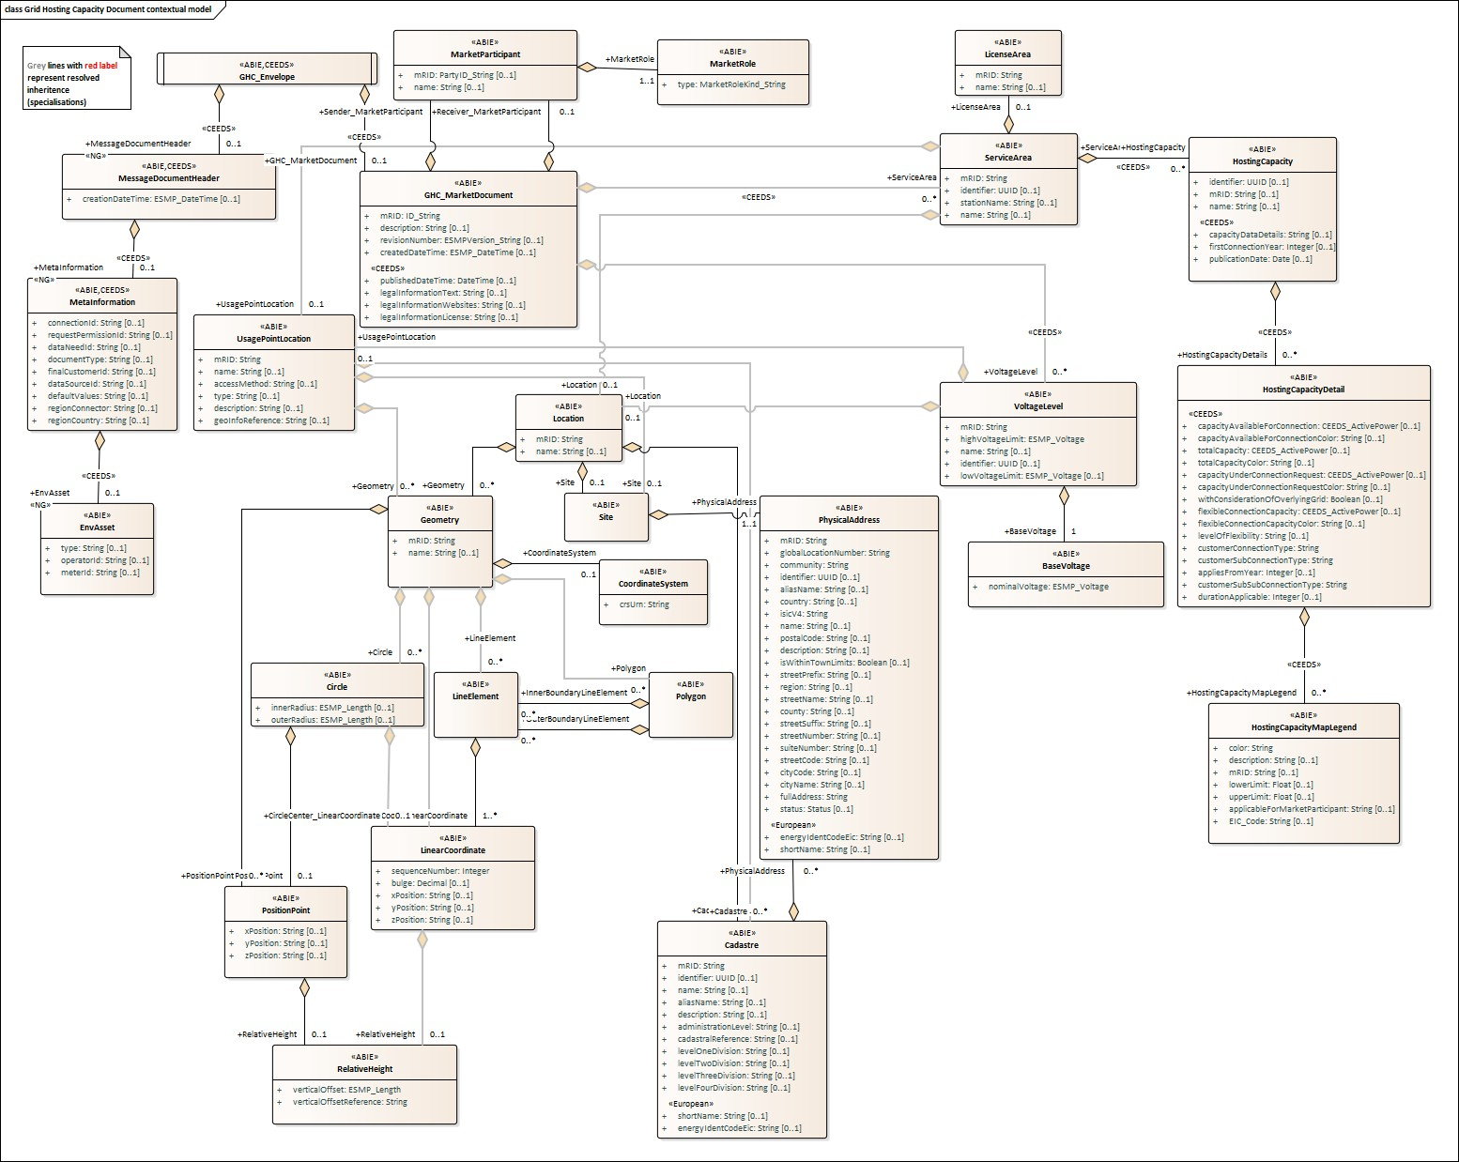

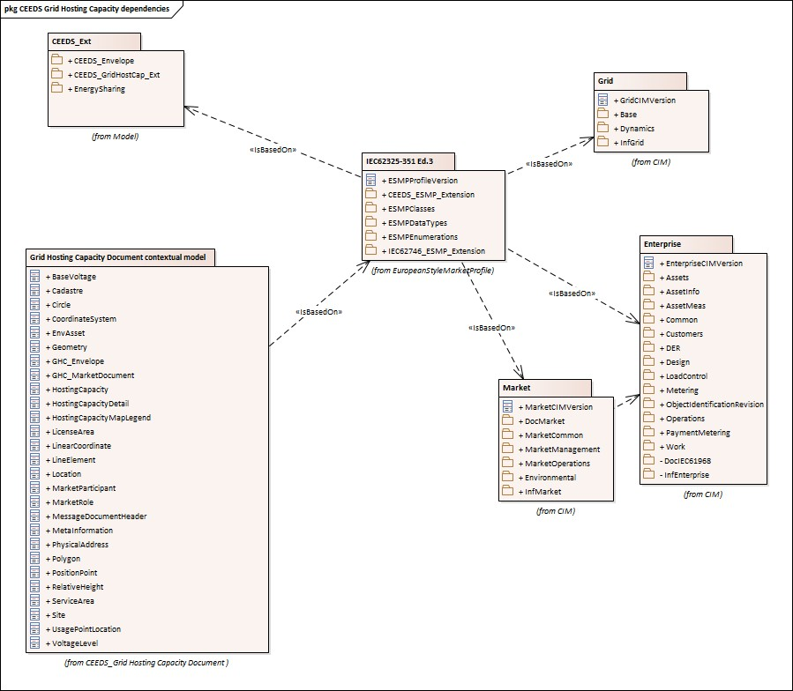

Figure !# - Grid Hosting Capacity Document contextual model

IsBasedOn relationships from the European style market profile

!# shows the traceability dependency of the classes used in this package towards the upper level. Table !# - IsBasedOn dependency

Name Complete IsBasedOn Path
BaseVoltage CIMProfiles::MarketProfiles::RD_Projects::CEEDS::CEEDS_Grid Hosting Capacity Document ::Grid Hosting Capacity Document contextual model::BaseVoltage

Cadastre CIMProfiles::MarketProfiles::RD_Projects::CEEDS::CEEDS_Grid Hosting Capacity Document ::Grid Hosting Capacity Document contextual model::Cadastre

Circle CIMProfiles::MarketProfiles::RD_Projects::CEEDS::CEEDS_Grid Hosting Capacity Document ::Grid Hosting Capacity Document contextual model::Circle

CoordinateSystem CIMProfiles::MarketProfiles::RD_Projects::CEEDS::CEEDS_Grid Hosting Capacity Document ::Grid Hosting Capacity Document contextual model::CoordinateSystem

EnvAsset CIMProfiles::MarketProfiles::RD_Projects::CEEDS::CEEDS_Grid Hosting Capacity Document ::Grid Hosting Capacity Document contextual model::EnvAsset

Geometry CIMProfiles::MarketProfiles::RD_Projects::CEEDS::CEEDS_Grid Hosting Capacity Document ::Grid Hosting Capacity Document contextual model::Geometry

GHC_Envelope CIMProfiles::MarketProfiles::RD_Projects::CEEDS::CEEDS_Grid Hosting Capacity Document ::Grid Hosting Capacity Document contextual model::GHC_Envelope

GHC_MarketDocument CIMProfiles::MarketProfiles::RD_Projects::CEEDS::CEEDS_Grid Hosting Capacity Document ::Grid Hosting Capacity Document contextual model::GHC_MarketDocument

HostingCapacity CIMProfiles::MarketProfiles::RD_Projects::CEEDS::CEEDS_Grid Hosting Capacity Document ::Grid Hosting Capacity Document contextual model::HostingCapacity

HostingCapacityDetail CIMProfiles::MarketProfiles::RD_Projects::CEEDS::CEEDS_Grid Hosting Capacity Document ::Grid Hosting Capacity Document contextual model::HostingCapacityDetail

HostingCapacityMapLegend CIMProfiles::MarketProfiles::RD_Projects::CEEDS::CEEDS_Grid Hosting Capacity Document ::Grid Hosting Capacity Document contextual model::HostingCapacityMapLegend

LicenseArea CIMProfiles::MarketProfiles::RD_Projects::CEEDS::CEEDS_Grid Hosting Capacity Document ::Grid Hosting Capacity Document contextual model::LicenseArea

LinearCoordinate CIMProfiles::MarketProfiles::RD_Projects::CEEDS::CEEDS_Grid Hosting Capacity Document ::Grid Hosting Capacity Document contextual model::LinearCoordinate

LineElement CIMProfiles::MarketProfiles::RD_Projects::CEEDS::CEEDS_Grid Hosting Capacity Document ::Grid Hosting Capacity Document contextual model::LineElement

Location CIMProfiles::MarketProfiles::RD_Projects::CEEDS::CEEDS_Grid Hosting Capacity Document ::Grid Hosting Capacity Document contextual model::Location

MarketParticipant CIMProfiles::MarketProfiles::RD_Projects::CEEDS::CEEDS_Grid Hosting Capacity Document ::Grid Hosting Capacity Document contextual model::MarketParticipant

MarketRole CIMProfiles::MarketProfiles::RD_Projects::CEEDS::CEEDS_Grid Hosting Capacity Document ::Grid Hosting Capacity Document contextual model::MarketRole

MessageDocumentHeader CIMProfiles::MarketProfiles::RD_Projects::CEEDS::CEEDS_Grid Hosting Capacity Document ::Grid Hosting Capacity Document contextual model::MessageDocumentHeader

MetaInformation CIMProfiles::MarketProfiles::RD_Projects::CEEDS::CEEDS_Grid Hosting Capacity Document ::Grid Hosting Capacity Document contextual model::MetaInformation

PhysicalAddress CIMProfiles::MarketProfiles::RD_Projects::CEEDS::CEEDS_Grid Hosting Capacity Document ::Grid Hosting Capacity Document contextual model::PhysicalAddress

Polygon CIMProfiles::MarketProfiles::RD_Projects::CEEDS::CEEDS_Grid Hosting Capacity Document ::Grid Hosting Capacity Document contextual model::Polygon

PositionPoint CIMProfiles::MarketProfiles::RD_Projects::CEEDS::CEEDS_Grid Hosting Capacity Document ::Grid Hosting Capacity Document contextual model::PositionPoint

RelativeHeight CIMProfiles::MarketProfiles::RD_Projects::CEEDS::CEEDS_Grid Hosting Capacity Document ::Grid Hosting Capacity Document contextual model::RelativeHeight

ServiceArea CIMProfiles::MarketProfiles::RD_Projects::CEEDS::CEEDS_Grid Hosting Capacity Document ::Grid Hosting Capacity Document contextual model::ServiceArea

Site CIMProfiles::MarketProfiles::RD_Projects::CEEDS::CEEDS_Grid Hosting Capacity Document ::Grid Hosting Capacity Document contextual model::Site

UsagePointLocation CIMProfiles::MarketProfiles::RD_Projects::CEEDS::CEEDS_Grid Hosting Capacity Document ::Grid Hosting Capacity Document contextual model::UsagePointLocation

VoltageLevel CIMProfiles::MarketProfiles::RD_Projects::CEEDS::CEEDS_Grid Hosting Capacity Document ::Grid Hosting Capacity Document contextual model::VoltageLevel

##MXM##

Grid Hosting Capacity Document assembly model

Overview of the model

!# shows the model.

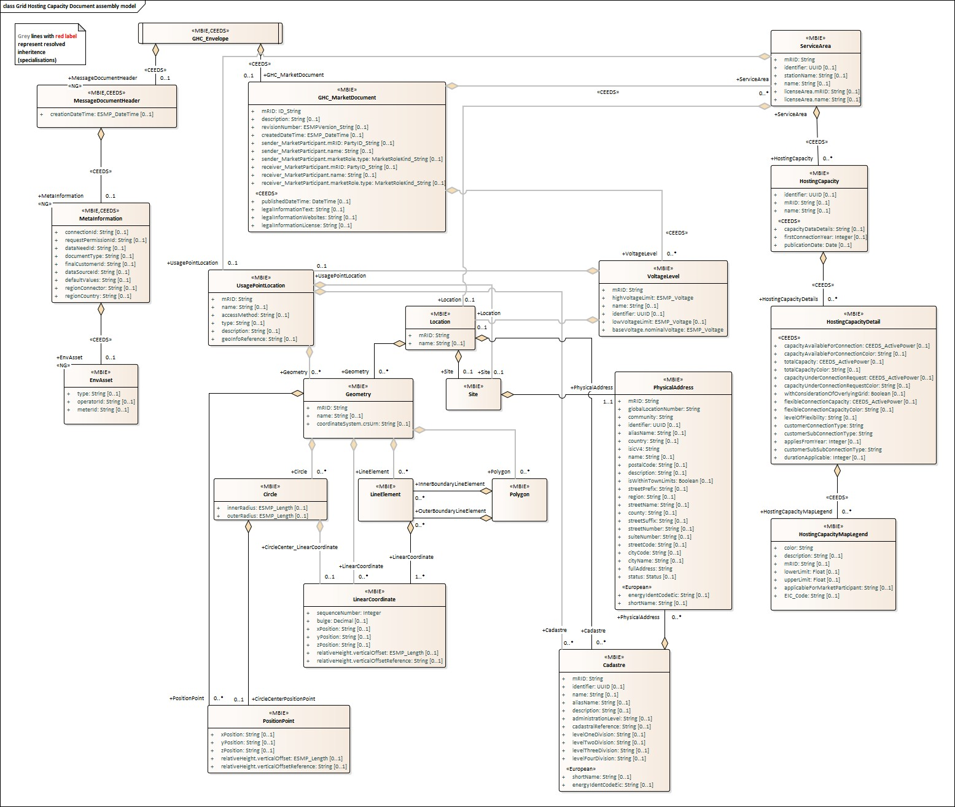

Figure !# - Grid Hosting Capacity Document assembly model

IsBasedOn relationships from the European style market profile

!# shows the traceability dependency of the classes used in this package towards the upper level. Table !# - IsBasedOn dependency

Name Complete IsBasedOn Path
Cadastre CIMProfiles::MarketProfiles::RD_Projects::CEEDS::CEEDS_Grid Hosting Capacity Document ::Grid Hosting Capacity Document assembly model::Cadastre

Circle CIMProfiles::MarketProfiles::RD_Projects::CEEDS::CEEDS_Grid Hosting Capacity Document ::Grid Hosting Capacity Document assembly model::Circle

EnvAsset CIMProfiles::MarketProfiles::RD_Projects::CEEDS::CEEDS_Grid Hosting Capacity Document ::Grid Hosting Capacity Document assembly model::EnvAsset

Geometry CIMProfiles::MarketProfiles::RD_Projects::CEEDS::CEEDS_Grid Hosting Capacity Document ::Grid Hosting Capacity Document assembly model::Geometry

GHC_Envelope CIMProfiles::MarketProfiles::RD_Projects::CEEDS::CEEDS_Grid Hosting Capacity Document ::Grid Hosting Capacity Document assembly model::GHC_Envelope

GHC_MarketDocument CIMProfiles::MarketProfiles::RD_Projects::CEEDS::CEEDS_Grid Hosting Capacity Document ::Grid Hosting Capacity Document assembly model::GHC_MarketDocument

HostingCapacity CIMProfiles::MarketProfiles::RD_Projects::CEEDS::CEEDS_Grid Hosting Capacity Document ::Grid Hosting Capacity Document assembly model::HostingCapacity

HostingCapacityDetail CIMProfiles::MarketProfiles::RD_Projects::CEEDS::CEEDS_Grid Hosting Capacity Document ::Grid Hosting Capacity Document assembly model::HostingCapacityDetail

HostingCapacityMapLegend CIMProfiles::MarketProfiles::RD_Projects::CEEDS::CEEDS_Grid Hosting Capacity Document ::Grid Hosting Capacity Document assembly model::HostingCapacityMapLegend

LinearCoordinate CIMProfiles::MarketProfiles::RD_Projects::CEEDS::CEEDS_Grid Hosting Capacity Document ::Grid Hosting Capacity Document assembly model::LinearCoordinate

LineElement CIMProfiles::MarketProfiles::RD_Projects::CEEDS::CEEDS_Grid Hosting Capacity Document ::Grid Hosting Capacity Document assembly model::LineElement

Location CIMProfiles::MarketProfiles::RD_Projects::CEEDS::CEEDS_Grid Hosting Capacity Document ::Grid Hosting Capacity Document assembly model::Location

MessageDocumentHeader CIMProfiles::MarketProfiles::RD_Projects::CEEDS::CEEDS_Grid Hosting Capacity Document ::Grid Hosting Capacity Document assembly model::MessageDocumentHeader

MetaInformation CIMProfiles::MarketProfiles::RD_Projects::CEEDS::CEEDS_Grid Hosting Capacity Document ::Grid Hosting Capacity Document assembly model::MetaInformation

PhysicalAddress CIMProfiles::MarketProfiles::RD_Projects::CEEDS::CEEDS_Grid Hosting Capacity Document ::Grid Hosting Capacity Document assembly model::PhysicalAddress

Polygon CIMProfiles::MarketProfiles::RD_Projects::CEEDS::CEEDS_Grid Hosting Capacity Document ::Grid Hosting Capacity Document assembly model::Polygon

PositionPoint CIMProfiles::MarketProfiles::RD_Projects::CEEDS::CEEDS_Grid Hosting Capacity Document ::Grid Hosting Capacity Document assembly model::PositionPoint

ServiceArea CIMProfiles::MarketProfiles::RD_Projects::CEEDS::CEEDS_Grid Hosting Capacity Document ::Grid Hosting Capacity Document assembly model::ServiceArea

Site CIMProfiles::MarketProfiles::RD_Projects::CEEDS::CEEDS_Grid Hosting Capacity Document ::Grid Hosting Capacity Document assembly model::Site

UsagePointLocation CIMProfiles::MarketProfiles::RD_Projects::CEEDS::CEEDS_Grid Hosting Capacity Document ::Grid Hosting Capacity Document assembly model::UsagePointLocation

VoltageLevel CIMProfiles::MarketProfiles::RD_Projects::CEEDS::CEEDS_Grid Hosting Capacity Document ::Grid Hosting Capacity Document assembly model::VoltageLevel

##MXM##

Detailed Grid Hosting Capacity Document assembly model

GHC_Envelope root class

The envelope entity is a non-CIM object used in an energy data space environment to serve as a central top-level entity connecting the MarketDocumentHeader (energy data space specific context information block) with the regular CIM MarketDocument.

!# shows all association ends of GHC_Envelope with other classes.

Table !# - Association ends of Grid Hosting Capacity Document assembly model::GHC_Envelope with other classes

Order mult. Class name / Role Description

- [0..1] MessageDocumentHeader
Association Based On :
MessageDocumentHeader Grid Hosting Capacity Document contextual model::GHC_Envelope. []

Grid Hosting Capacity Document contextual model::MessageDocumentHeader.MessageDocumentHeader[0..1]

- [0..1] GHC_MarketDocument
Association Based On :
GHC_MarketDocument Grid Hosting Capacity Document contextual model::GHC_Envelope. []

Grid Hosting Capacity Document contextual model::GHC_MarketDocument.GHC_MarketDocument[0..1]

##MXM##

Cadastre

A singular complete record of all land parcels within some hierarchical level of administrative jurisdiction. The cadastre provides the ability to find the results of land parcel surveys typically used for land management and planning.

!# shows all attributes of Cadastre.

Table !# - Attributes of Grid Hosting Capacity Document assembly model::Cadastre
Order mult. Attribute name / Description Attribute type
0 [1..1] mRID Master resource identifier issued by a model authority. The mRID is unique within an exchange context. Global uniqueness is easily achieved by using a UUID, as
String specified in IETF RFC 4122, for the mRID. The use of UUID is strongly
recommended.
For CIMXML data files in RDF syntax conforming to IEC 61970-552, the mRID is mapped to rdf:ID or rdf:about attributes that identify CIM object elements.
1 [0..1] identifier A universally unique object identifier. Used to uniquely identify persistent objects between CIM messages.
UUID
2 [0..1] name The name is any free human readable and possibly non unique text naming the object.
String
3 [0..1] shortName The attribute is used for an exchange of a human readable short name with length of the string 12 characters maximum.
String
4 [0..1] aliasName The aliasName is free text human readable name of the object alternative to IdentifiedObject.name. It may be non unique and may not correlate to a naming
String hierarchy.
The attribute aliasName is retained because of backwards compatibility between CIM releases. It is however recommended to replace aliasName with the Name class as aliasName is planned for retirement at a future time.
5 [0..1] description The description is a free human readable text describing or naming the object. It may be non unique and may not correlate to a naming hierarchy.
String
6 [0..1] administrationLevel Administrative level is referring to the organisation that is administrative authority for managing the a hierarchical division of a geographic area into land, property
String groups. This typically established by government that has the responsibility of
managing governance, services, taxation, and legal jurisdiction, such as municipalities, townships, counties, or regions.
7 [0..1] cadastralReference Local or national unique identification reference for the cadastral for land parcel, ensuring effective land management, ownership tracking, and legal compliance.
String
8 [0..1] energyIdentCodeEic The attribute is used for an exchange of the EIC code (Energy identification Code). The length of the string is 16 characters as defined by the EIC code. For
String details on EIC scheme please refer to ENTSO-E web site.
9 [0..1] levelOneDivision Level One Division refers to the highest organizational or reference unit within a cadastral hierarchy, typically representing a primary division of land, such as a
String farm or property group, which can be further subdivided into smaller parcels.
10 [0..1] levelTwoDivision Level Two Division refers to a subdivision of a Level One Parcel within a cadastral hierarchy, representing smaller, distinct land units typically used for individual
String ownership, usage, or development, such as specific plots or lots within a farm or
property group.
11 [0..1] levelThreeDivision Level Three Division refers to a further subdivision of a Level Two Division within a cadastral hierarchy, typically used to represent specialized land units such as
String

leased parcels, easements, or other secondary divisions associated with distinct legal or usage rights.
12 [0..1] levelFourDivision Level Four Division refers to a further subdivision of a Level Three Division within a cadastral hierarchy, typically used to represent specific units or sections within a
String shared property or structure, such as apartments, condominiums, or co-owned
facilities.

##MXM##

!# shows all association ends of Cadastre with other classes.

Table !# - Association ends of Grid Hosting Capacity Document assembly model::Cadastre with other classes
Order mult. Class name / Description
Role
13 [0..*] PhysicalAddress Physical addresses encompassed within a given cadastre. Association Based On :
PhysicalAddress Grid Hosting Capacity Document contextual model::Cadastre.[]

Grid Hosting Capacity Document contextual model::PhysicalAddress.PhysicalAddress[0..*]

##MXM##

Circle

A circular area in space, described by a center point and radius. Any circle object must have a center and an outer radius and may have an inner radius. If an inner radius is specified, the area within the inner radius is to be excluded from the area within the outer radius, forming a ring shape.

!# shows all attributes of Circle.

Table !# - Attributes of Grid Hosting Capacity Document assembly model::Circle
Order mult. Attribute name / Description Attribute type
0 | [0..1] innerRadius A circle may have an inner radius. If specified the area described by the inner radius is to be excluded from the area within the outer radius, forming a ring shape.  ESMP_Length
1 [0..1] outerRadius Every circle must have an outer radius which describes the outer limit of the circular area.
ESMP_Length

##MXM##

!# shows all association ends of Circle with other classes.

Table !# - Association ends of Grid Hosting Capacity Document assembly model::Circle with other classes
Order mult. Class name / Role Description
2 | [0..1] PositionPoint A point representing the center of a circular area. Any circle  object must have one CircleCenter.  CircleCenterPositionPoint Association Based On :  Grid Hosting Capacity Document contextual model::Circle.[]  Grid Hosting Capacity Document contextual model::PositionPoint.CircleCenterPositionPoint[0..1]
3 | [0..1] LinearCoordinate A point representing the center of a circular area. Any circle  object must have one CircleCenter.  CircleCenter_LinearCoordinate Association Based On :  Grid Hosting Capacity Document contextual model::Circle.[]

Grid Hosting Capacity Document contextual model::LinearCoordinate.CircleCenter_LinearCoordinate[0..1]

##MXM##

EnvAsset

EnvAsset is an energy data space specific attribute referring to the Asset from which data is being requested

!# shows all attributes of EnvAsset.

Table !# - Attributes of Grid Hosting Capacity Document assembly model::EnvAsset
Order mult. Attribute name /  Attribute type | Description
0 [0..1] type  String | type is an energy data space specific attribute that specifies type of asset refered to.
1 [0..1] operatorId  String | operatorId is an energy data space specific attribute that specifies the id operator of the asset refered to.
2 [0..1] meterId String  ##MXM## | meterId is an energy data space specific attribute that specifies the id of the meter that measures the asset.

Geometry

Geo-spatial representation of a physical location. A location may be represented as a Point, Line, Polygon, or Circle.

!# shows all attributes of Geometry.

Table !# - Attributes of Grid Hosting Capacity Document assembly model::Geometry
Order mult. Attribute name / Attribute Description type
0 | [1..1] mRID Master resource identifier issued by a model authority. The mRID is unique within an exchange context. Global uniqueness is easily achieved by using a  String UUID, as specified in IETF RFC 4122, for the mRID. The use of UUID is  strongly recommended.  For CIMXML data files in RDF syntax conforming to IEC 61970-552, the mRID is mapped to rdf:ID or rdf:about attributes that identify CIM object elements.
1 | [0..1] name The name is any free human readable and possibly non unique text naming the object.  String
2 | [0..1] coordinateSystem.crsUrn A Uniform Resource Name (URN) for the coordinate reference system (crs) used to define 'Location.PositionPoints'.  String An example would be the European Petroleum Survey Group (EPSG) code  for a coordinate reference system, defined in URN under the Open Geospatial Consortium (OGC) namespace as: urn:ogc:def:uom:EPSG::XXXX, where XXXX is an EPSG code (a full list of codes can be found at the EPSG Registry web site http://www.epsg- registry.org/). To define the coordinate system as being WGS84 (latitude, longitude) using an EPSG OGC, this attribute would be

urn:ogc:def:uom:EPSG::4236.
A profile should limit this code to a set of allowed URNs agreed to by all sending and receiving parties.
--- The coordinate system used for a given geometry.

##MXM##

!# shows all association ends of Geometry with other classes.

Table !# - Association ends of Grid Hosting Capacity Document assembly model::Geometry with other classes Order mult. Class name / Description
Role

- [0..*] PositionPoint
Association Based On :
PositionPoint Grid Hosting Capacity Document contextual model::Geometry.[]

Grid Hosting Capacity Document contextual model::PositionPoint.PositionPoint[0..*]

- [0..*] LineElement
Association Based On :
LineElement Grid Hosting Capacity Document contextual model::Geometry.[]

Grid Hosting Capacity Document contextual model::LineElement.LineElement[0..*]

- [0..*] Polygon
Association Based On :
Polygon Grid Hosting Capacity Document contextual model::Geometry.[]

Grid Hosting Capacity Document contextual model::Polygon.Polygon[0..*]

- [0..*] Circle
Association Based On :
Circle Grid Hosting Capacity Document contextual model::Geometry.[]

Grid Hosting Capacity Document contextual model::Circle.Circle[0..*]

- [0..*] LinearCoordinate
Association Based On :
LinearCoordinate Grid Hosting Capacity Document contextual model::Geometry.[]

Grid Hosting Capacity Document contextual model::LinearCoordinate.LinearCoordinate[0..*]

##MXM##

GHC_MarketDocument

An electronic document containing the information necessary to satisfy the requirements of a given business process.

!# shows all attributes of GHC_MarketDocument.

Table !# - Attributes of Grid Hosting Capacity Document assembly model::GHC_MarketDocument Order mult. Attribute name / Attribute type Description
0 [1..1] mRID The unique identification of the document being exchanged within a business process flow.
ID_String
In the ESMP context, the "model authority" is defined as a party (originator of the exchange) that provides an identification in the context of a business exchange such

as document identification, ...

Master resource identifier issued by a model authority. The mRID is globally unique within an exchange context. Global uniqueness is easily achieved by using a UUID for the mRID. It is strongly recommended to do this.
For CIMXML data files in RDF syntax, the mRID is mapped to rdf:ID or rdf:about attributes that identify CIM object elements.

- [0..1] description The description is a free human readable text describing or naming the object. It may be non unique and may not
String correlate to a naming hierarchy.

- [0..1] publishedDateTime The date time the legal information is published

DateTime

- [0..1] revisionNumber The identification of the version that distinguishes one evolution of a document from another.
ESMPVersion_String

- [0..1] legalInformationText Text with the required legal information from the information provider (Connecting System operator=CSO)
String

- [0..1] legalInformationWebsites
URL pointing to the required legal information from the
String information provider (Connecting System operator=CSO)

- [0..1] legalInformationLicense

String

- [0..1] createdDateTime The date and time of the creation of the document.

ESMP_DateTime

- [0..1] sender_MarketParticipant.mRID The identification of a party in the energy market.

PartyID_String In the ESMP context, the "model authority" is defined as an authorized issuing office that provides an agreed identification coding scheme for market participant, domain, measurement point, resources (generator, lines, substations, etc.) identification.

Master resource identifier issued by a model authority. The mRID is globally unique within an exchange context. Global uniqueness is easily achieved by using a UUID for the mRID. It is strongly recommended to do this.
For CIMXML data files in RDF syntax, the mRID is mapped to rdf:ID or rdf:about attributes that identify CIM object elements.

- [0..1] sender_MarketParticipant.name The name is any free human readable and possibly non
unique text naming the object.
String

- [0..1] sender_MarketParticipant.marketRole.type The identification of the role played by a market player.

MarketRoleKind_String

- [0..1] receiver_MarketParticipant.mRID The identification of a party in the energy market.

PartyID_String In the ESMP context, the "model authority" is defined as an authorized issuing office that provides an agreed identification coding scheme for market participant, domain, measurement point, resources (generator, lines, substations, etc.) identification.

Master resource identifier issued by a model authority.

The mRID is globally unique within an exchange context. Global uniqueness is easily achieved by using a UUID for the mRID. It is strongly recommended to do this.
For CIMXML data files in RDF syntax, the mRID is mapped to rdf:ID or rdf:about attributes that identify CIM object elements.

- [0..1] receiver_MarketParticipant.name The name is any free human readable and possibly non
unique text naming the object.
String

- [0..1] receiver_MarketParticipant.marketRole.type The identification of the role played by a market player.

MarketRoleKind_String

##MXM##

!# shows all association ends of GHC_MarketDocument with other classes.

Table !# - Association ends of Grid Hosting Capacity Document assembly model::GHC_MarketDocument with other classes

Order mult. Class name / Description
Role

- [0..*] VoltageLevel
Association Based On :
VoltageLevel Grid Hosting Capacity Document contextual model::GHC_MarketDocument.[]

Grid Hosting Capacity Document contextual model::VoltageLevel.VoltageLevel[0..*]

- [0..*] ServiceArea
Association Based On :
ServiceArea Grid Hosting Capacity Document contextual model::GHC_MarketDocument.[]

Grid Hosting Capacity Document contextual model::ServiceArea.ServiceArea[0..*]

##MXM##

HostingCapacity

A structure for a set of information on grid hosting capacity.

!# shows all attributes of HostingCapacity.

Table !# - Attributes of Grid Hosting Capacity Document assembly model::HostingCapacity Order mult. Attribute name / Description
Attribute type

- [0..1] identifier A universally unique object identifier. Used to uniquely identify persistent objects between CIM messages.
UUID

- [0..1] capacityDataDetails Informational field for further information on

String
timing (e.g. is time for capacity available for connection a snapshot or is it the time when connection can be performed)

description of the SO description of the data provided,

description of the meaning of the different colours

- [0..1] mRID Master resource identifier issued by a model authority. The mRID is unique within an exchange context. Global uniqueness is easily achieved by using a UUID, as
String specified in IETF RFC 4122, for the mRID. The use of UUID is strongly
recommended.
For CIMXML data files in RDF syntax conforming to IEC 61970-552, the mRID is mapped to rdf:ID or rdf:about attributes that identify CIM object elements.

- [0..1] firstConnectionYear The year that the capacity is applicable.

Integer

- [0..1] name The name is any free human readable and possibly non unique text naming the object.
String

- [0..1] publicationDate The date when the data was produced or when it can be available Date
##MXM##

!# shows all association ends of HostingCapacity with other classes.

Table !# - Association ends of Grid Hosting Capacity Document assembly model::HostingCapacity with other classes

Order mult. Class name / Role Description

- [0..*] HostingCapacityDetail
Association Based On :
HostingCapacityDetails Grid Hosting Capacity Document contextual model::HostingCapacity.[]

Grid Hosting Capacity Document contextual model::HostingCapacityDetail.HostingCapacityDetails[0..*]

##MXM##

HostingCapacityDetail

!# shows all attributes of HostingCapacityDetail.

Table !# - Attributes of Grid Hosting Capacity Document assembly model::HostingCapacityDetail Order mult. Attribute name / Attribute type Description
- [0..1] capacityAvailableForConnection

CEEDS_ActivePower

- [0..1] capacityAvailableForConnectionColor

String

- [0..1] totalCapacity

CEEDS_ActivePower

- [0..1] totalCapacityColor

String

- [0..1] capacityUnderConnectionRequest

CEEDS_ActivePower

- [0..1] capacityUnderConnectionRequestColor

String

- [0..1] withConsiderationOfOverlyingGrid

Boolean

- [0..1] flexibleConnectionCapacity

CEEDS_ActivePower

- [0..1] flexibleConnectionCapacityColor

String

- [0..1] levelOfFlexibility

String

- [1..1] customerConnectionType

String

- [1..1] customerSubConnectionType

String

- [0..1] appliesFromYear

Integer

- [1..1] customerSubSubConnectionType

String

- [0..1] durationApplicable Integer
##MXM##

!# shows all association ends of HostingCapacityDetail with other classes.

Table !# - Association ends of Grid Hosting Capacity Document assembly model::HostingCapacityDetail with other classes
Order | mult. | Class name / Role | Description
15 [0..*] HostingCapacityMapLegend  Association Based On :  HostingCapacityMapLegend Grid Hosting Capacity Document contextual  model::HostingCapacityDetail.[]  Grid Hosting Capacity Document contextual model::HostingCapacityMapLegend.HostingCapacityMapLegend[0..*  ##MXM## |  |  |  | ]

HostingCapacityMapLegend

!# shows all attributes of HostingCapacityMapLegend.

Table !# - Attributes of Grid Hosting Capacity Document assembly model::HostingCapacityMapLegend Order mult. Attribute name / Attribute type Description
0 [1..1] color

String

1 [0..1] description The description is a free human readable text describing or naming the
object. It may be non unique and may not correlate to a naming
String hierarchy.

2 | [0..1] mRID  String | Master resource identifier issued by a model authority. The mRID is unique within an exchange context. Global uniqueness is easily achieved by using a UUID, as specified in IETF RFC 4122, for the mRID. The use of UUID is strongly recommended.  For CIMXML data files in RDF syntax conforming to IEC 61970-552, the mRID is mapped to rdf:ID or rdf:about attributes that identify CIM  object elements.
3 | [0..1] lowerLimit  Float
4 | [0..1] upperLimit  Float
5 | [0..1] applicableForMarketParticipant  String
6 [0..1] EIC_Code

String

##MXM##

LinearCoordinate

Specifies a point on a line segment, including a sequence number and bulge. To visualize the line segment, each linear coordinate is to be connected in the order specified by the sequence attribute. Each linear coordinate must have a sequence value.

!# shows all attributes of LinearCoordinate.

Table !# - Attributes of Grid Hosting Capacity Document assembly model::LinearCoordinate
Order mult. Attribute name / Attribute type |  | Description
0 | [1..1] sequenceNumber  Integer | The order in which linear coordinates are to be connected to form the line described. Sequence is required for all linear coordinates.
1 | [0..1] bulge  Decimal | Bulge is a factor that describes a curved line segment between two points. bulge=0 is a straight line: bulge=1 is a curve along the edge of a circle. A bulge can be associated only with the second point of a line segment. A negative bulge factor causes the line to bulge to the left as viewed from the first point to the second; a positive bulge causes the line to be curved to the right as viewed from the first point to the second.
2 | [0..1] xPosition  String | X axis position.
3 | [0..1] yPosition  String | Y axis position.
4 | [0..1] zPosition  String | (if applicable) Z axis position.
5 | [0..1] relativeHeight.verticalOffset ESMP_Length | Distance above (positive value) or below (negative value) the specified vertical offset reference.
6 | [0..1] relativeHeight.verticalOffsetReference The height from which vertical offset is measured. Examples  include â€œGround Levelâ€ , â€œPole Topâ€ , â€œTower

String Topâ€ , etc.
##MXM##

LineElement

A geometric line segment, described by 2 or more coordinate tuples with linear interpolation between them. A line must contain at least 2 linear coordinates.

!# shows all association ends of LineElement with other classes.

Table !# - Association ends of Grid Hosting Capacity Document assembly model::LineElement with other classes Order mult. Class name / Description
Role

0 [1..*] LinearCoordinate The linear coordinates which define a line with one or more segments.
Association Based On :
LinearCoordinate Grid Hosting Capacity Document contextual model::LineElement.[]

Grid Hosting Capacity Document contextual model::LinearCoordinate.LinearCoordinate[1..*]

##MXM##

Location

The place, scene, or point of something where someone or something has been, is, and/or will be at a given moment in time. It can be defined with one or more position points (coordinates) in a given coordinate system.

!# shows all attributes of Location.

Table !# - Attributes of Grid Hosting Capacity Document assembly model::Location Order mult. Attribute Description
name /
Attribute type

- [1..1] mRID The unique identification of a location.

String In the ESMP context, the "model authority" is defined as an authorized issuing office that provides an agreed identification coding scheme for market participant, domain, measurement point, resources (generator, lines, substations, etc.) identification, location, etc.

Master resource identifier issued by a model authority. The mRID is globally unique within an exchange context.
Global uniqueness is easily achieved by using a UUID for the mRID. It is strongly recommended to do this.
For CIMXML data files in RDF syntax, the mRID is mapped to rdf:ID or rdf:about attributes that identify CIM object elements.

- [0..1] name The name is any free human readable and possibly non unique text naming the object.

String

##MXM##

!# shows all association ends of Location with other classes.

Table !# - Association ends of Grid Hosting Capacity Document assembly model::Location with other classes Order mult. Class name / Description
Role

2 [0..*] Geometry The geometry for a given location.
Association Based On :
Geometry Grid Hosting Capacity Document contextual model::Location.[]

Grid Hosting Capacity Document contextual model::Geometry.Geometry[0..*]

3 [0..1] Site
Association Based On :
Site Grid Hosting Capacity Document contextual model::Location.[]

Grid Hosting Capacity Document contextual model::Site.Site[0..1]

4 [0..*] Cadastre Cadastre encompassing a location.
Association Based On :
Cadastre Grid Hosting Capacity Document contextual model::Location.[]

Grid Hosting Capacity Document contextual model::Cadastre.Cadastre[0..*]

##MXM##

MessageDocumentHeader

MessageDocumentHeader is an energy data space specific entity with the creationDateTime of this document.

!# shows all attributes of MessageDocumentHeader.

Table !# - Attributes of Grid Hosting Capacity Document assembly model::MessageDocumentHeader Order mult. Attribute name / Attribute type Description
- [0..1] creationDateTime The date and time the MessageDocumenHeader was created.

ESMP_DateTime

##MXM##

!# shows all association ends of MessageDocumentHeader with other classes.

Table !# - Association ends of Grid Hosting Capacity Document assembly model::MessageDocumentHeader with other classes

Order mult. Class name / Description
Role

- [0..1] MetaInformation
Association Based On :
MetaInformation Grid Hosting Capacity Document contextual model::MessageDocumentHeader.[]

Grid Hosting Capacity Document contextual model::MetaInformation.MetaInformation[0..1]

##MXM##

MetaInformation

MetaInformation is an energy data space specific entity referring to the information concerning the technical and functional context of the MarketDocument.

!# shows all attributes of MetaInformation.

Table !# - Attributes of Grid Hosting Capacity Document assembly model::MetaInformation Order mult. Attribute name / Description
Attribute type

- [0..1] connectionId connectionId is an energy data space specific attribute referring to the established connection used for the communication of this document.
String

- [0..1] requestPermissionId The requestPermissionId is energy data space specific identification attribute holding an unique identifier issued by the energy data space to allow for tracing of
String the permission through serveral message exchanges.
Note: the requestPermissionId is NOT the identifier issued by the Identity Service Provider as specified in the EU Implementing Act on access to Metering and Consumption Data.

- [0..1] dataNeedId dataNeedId is an energy data space specific attribute holding the type of data need requested, like â€˜last 24 hours at 1 hour intervalâ€ .
String

- [0..1] documentType documentType is an energy data space specific attribute referring to the type of document, comparable to the MessageTypeList in the CIM part of the message.
String Note:
This is applicable if you have the need to know the content without having to open the complete document. DocumentType might contain messages not (yet) part of the MessageTypeList.

- [0..1] finalCustomerId The finalCustomerId is an energy data space specific attribute identifying the actor doing the request for data or data sharing.
String

- [0..1] dataSourceId dataSourceId is an energy data space specific attribute referring to the
datasource from which the requested data is being queried.
String

- [0..1] defaultValues defaultValues is a energy data space specific attribute to hold relevant default values. The format to use can freely be chosen based on the implementation.
String Most commonly you would expect a semi-colon separated name value pair, like:
"minPower=value; maxPower=value; avgPower=value".

- [0..1] regionConnector regionConnector is an energy data space specific attribute that specifies the regional connector being used to retrieve the data requested.
String

- [0..1] regionCountry regionCountry is an energy data space specific attribute that specifies the country where the regional connector is located.
String

##MXM##

!# shows all association ends of MetaInformation with other classes.

Table !# - Association ends of Grid Hosting Capacity Document assembly model::MetaInformation with other classes

Order mult. Class name / Role Description

- [0..1] EnvAsset
Association Based On :
EnvAsset Grid Hosting Capacity Document contextual model::MetaInformation.[]

Grid Hosting Capacity Document contextual model::EnvAsset.EnvAsset[0..1]

##MXM##

PhysicalAddress

The structured geographic and administrative context of a physical place where an organisation, person, or activity is located.

PhysicalAddress is used for precisely identifying, classifying, and locating entities for regulatory, logistical, or informational purposes.

!# shows all attributes of PhysicalAddress.

Table !# - Attributes of Grid Hosting Capacity Document assembly model::PhysicalAddress Order mult. Attribute name / Description
Attribute type

- [1..1] mRID Master resource identifier issued by a model authority. The mRID is unique
within an exchange context. Global uniqueness is easily achieved by using a String UUID, as specified in IETF RFC 4122, for the mRID. The use of UUID is
strongly recommended.
For CIMXML data files in RDF syntax conforming to IEC 61970-552, the mRID is mapped to rdf:ID or rdf:about attributes that identify CIM object elements.

- [1..1] globalLocationNumber Global Location Number (GLN, sometimes also referred to as International
Location Number or ILN) of the respective organization, person, or place. The String GLN is a 13-digit number used to identify parties and physical locations.

- [0..1] energyIdentCodeEic The attribute is used for an exchange of the EIC code (Energy identification
Code). The length of the string is 16 characters as defined by the EIC code. For String details on EIC scheme please refer to ENTSO-E web site.

- [1..1] community Community in which the locality is, and which is in the municipality, city or
town.. For example, Anderston, Glasgow City, Scotland or another appropriate String fourth-level administrative division

- [0..1] identifier A universally unique object identifier. Used to uniquely identify persistent
objects between CIM messages.
UUID

- [0..1] aliasName The aliasName is free text human readable name of the object alternative to
IdentifiedObject.name. It may be non unique and may not correlate to a naming String hierarchy.
The attribute aliasName is retained because of backwards compatibility between CIM releases. It is however recommended to replace aliasName with the Name class as aliasName is planned for retirement at a future time.

- [0..1] country Name of the country in which the address is located. It is recommended to use
either the 3-letter ISO 3166-1 alpha 3 code such as "SGP," or the full country String name such as "Singapore."

- [1..1] isicV4 International Standard of Industrial Classification of All Economic Activities
(ISIC), Revision 4 code for a particular organization, business person, or place.
String

- [0..1] name The name is any free human readable and possibly non unique text naming the
object.
String

- [0..1] postalCode Postal code for the address.

String

- [0..1] shortName The attribute is used for an exchange of a human readable short name with
length of the string 12 characters maximum.
String

- [0..1] description The description is a free human readable text describing or naming the object.
It may be non unique and may not correlate to a naming hierarchy.
String

- [0..1] isWithinTownLimits If TRUE, this street is within the legal geographical boundaries of the specified
town (default).
Boolean

- [0..1] streetPrefix Prefix to the street name. For example: North, South, East, West.

String

- [0..1] region Name of the first-level Administrative division of a country in which the address
is located. For example, California, Quebec, and Queensland are states and String provinces of the United States of America, Canada, and Australia, respectively.

- [0..1] streetName Name of the street.

String

- [0..1] county Name of the second-level Administrative division of a country in which the
address is located. The term used for the second-level Administrative division in String a county varies from country to country and between first-level Administrative
divisions within a country. For example, California has counties, Louisiana has parishes, British Columbia, Canada has regional districts, and Queensland Australia has shires and regions. Counties are usually made up of cities, towns, and rural populations.

- [0..1] streetSuffix Suffix to the street name. For example: North, South, East, West.

String

- [0..1] streetNumber Designator of the specific location on the street.

String

- [0..1] suiteNumber Number of the apartment or suite.

String

- [0..1] streetCode (if applicable) Utilities often make use of external reference systems, such as
those of the town-planner's department or surveyor general's mapping system, String that allocate global reference codes to streets.

- [0..1] cityCode City code.

String

- [0..1] cityName Name of the city.

String

- [1..1] fullAddress A concatenated string specifying the complete address in a single string which
may include delimiters.
String

- [0..1] status Current status of the address e.g. pending, approved Status
##MXM##

Polygon

One or more self-closing line segments representing a polygonal area. In order to be self-closing, the first and last linear coordinates of each line segment must be identical. A polygon must have one outer boundary and may have one or more inner boundaries. If an inner boundary is specified, the area within the inner boundary is to be excluded from the area within the outer boundary. Each line description within a polygon (both outer and inner boundaries) must contain at least 4 linear coordinates.

!# shows all association ends of Polygon with other classes.

Table !# - Association ends of Grid Hosting Capacity Document assembly model::Polygon with other classes Order mult. Class name / Role Description
0 [0..*] LineElement Optional for all polygons. If specified, an inner boundary must
contain at least 4 linear coordinates. The first and last coordinates InnerBoundaryLineElement in the sequence must be identical. The area described by an inner
boundary is to be excluded from the area described by the outer boundary in order to complete the description of a complex polygon. The entire area described by an inner boundary should

fall within the area described by the outer boundary. Association Based On :
Grid Hosting Capacity Document contextual model::Polygon.[]

Grid Hosting Capacity Document contextual model::LineElement.InnerBoundaryLineElement[0..*]

1 [0..*] LineElement One or more self-closing line segments representing a polygonal
area. In order to be self-closing, the first and last linear coordinates OuterBoundaryLineElement of each line segment must be identical. A polygon must have one
outer boundary and may have one or more inner boundaries. If an inner boundary is specified, the area within the inner boundary is to be excluded from the area within the outer boundary. Each line description within a polygon (both outer and inner boundaries) must contain at least 4 linear coordinates.
Association Based On :
Grid Hosting Capacity Document contextual model::Polygon.[]

Grid Hosting Capacity Document contextual model::LineElement.OuterBoundaryLineElement[0..*]

##MXM##

PositionPoint

Set of spatial coordinates that determine a point, defined in the coordinate system specified in 'Location.CoordinateSystem'. Use a single position point instance to describe a point-oriented location. Use a sequence of position points to describe a line-oriented object (physical location of non-point oriented objects like cables or lines), or area of an object (like a substation or a geographical zone - in this case, have first and last position point with the same values).

!# shows all attributes of PositionPoint.

Table !# - Attributes of Grid Hosting Capacity Document assembly model::PositionPoint Order mult. Attribute name / Attribute type Description
- [0..1] xPosition X axis position.

String

- [0..1] yPosition Y axis position.

String

- [0..1] zPosition (if applicable) Z axis position.

String

- [0..1] relativeHeight.verticalOffset Distance above (positive value) or below (negative value) the
specified vertical offset reference.
ESMP_Length

- [0..1] relativeHeight.verticalOffsetReference The height from which vertical offset is measured. Examples
include â€œGround Levelâ€ , â€œPole Topâ€ , â€œTower
String Topâ€ , etc.
##MXM##

ServiceArea

!# shows all attributes of ServiceArea.

Table !# - Attributes of Grid Hosting Capacity Document assembly model::ServiceArea Order mult. Attribute name / Description
Attribute type

- [1..1] mRID Master resource identifier issued by a model authority. The mRID is unique within an exchange context. Global uniqueness is easily achieved by using a UUID, as
String specified in IETF RFC 4122, for the mRID. The use of UUID is strongly
recommended.
For CIMXML data files in RDF syntax conforming to IEC 61970-552, the mRID is mapped to rdf:ID or rdf:about attributes that identify CIM object elements.

- [0..1] identifier A universally unique object identifier. Used to uniquely identify persistent objects between CIM messages.
UUID

- [0..1] stationName The human readable name of the station.

String

- [0..1] name The name is any free human readable and possibly non unique text naming the object.
String

- [0..1] licenseArea.mRID Master resource identifier issued by a model authority. The mRID is unique within an exchange context. Global uniqueness is easily achieved by using a UUID, as
String specified in IETF RFC 4122, for the mRID. The use of UUID is strongly
recommended.
For CIMXML data files in RDF syntax conforming to IEC 61970-552, the mRID is mapped to rdf:ID or rdf:about attributes that identify CIM object elements.

- [0..1] licenseArea.name The name is any free human readable and possibly non unique text naming the object.
String

##MXM##

!# shows all association ends of ServiceArea with other classes.

Table !# - Association ends of Grid Hosting Capacity Document assembly model::ServiceArea with other classes Order mult. Class name / Role Description
- [0..1] Location Location of this power system resource.
Association Based On :
Location Grid Hosting Capacity Document contextual model::Location.Location[0..1]

Grid Hosting Capacity Document contextual model::ServiceArea.[]

- [0..1] UsagePointLocation Location of this power system resource.
Association Based On :
UsagePointLocation Grid Hosting Capacity Document contextual model::ServiceArea.[]

Grid Hosting Capacity Document contextual model::UsagePointLocation.UsagePointLocation[0..1]

8 [0..*] HostingCapacity
Association Based On :
HostingCapacity Grid Hosting Capacity Document contextual
model::ServiceArea.ServiceArea[]

Grid Hosting Capacity Document contextual model::HostingCapacity.HostingCapacity[0..*]

##MXM##

Site

Area of ground on which work can be executed, organisation can be hosted, and building (including substation and power line) can be located.

!# shows all association ends of Site with other classes.

Table !# - Association ends of Grid Hosting Capacity Document assembly model::Site with other classes
Order mult. Class name / Description
Role
0 [1..1] PhysicalAddress
Association Based On :
PhysicalAddress Grid Hosting Capacity Document contextual model::Site.[]

Grid Hosting Capacity Document contextual model::PhysicalAddress.PhysicalAddress[1..1]

##MXM##

UsagePointLocation

Location of an individual usage point.

!# shows all attributes of UsagePointLocation.

Table !# - Attributes of Grid Hosting Capacity Document assembly model::UsagePointLocation
Order mult. Attribute name /  Attribute type |  | Description
0 | [1..1] mRID  String | The unique identification of a location.  In the ESMP context, the "model authority" is defined as an authorized issuing office that provides an agreed identification coding scheme for market participant, domain, measurement point, resources (generator, lines, substations, etc.) identification, location, etc.  Master resource identifier issued by a model authority. The mRID is globally unique within an exchange context.  Global uniqueness is easily achieved by using a UUID for the mRID. It is strongly recommended to do this.  For CIMXML data files in RDF syntax, the mRID is mapped to rdf:ID or rdf:about  attributes that identify CIM object elements.
1 | [0..1] name  String | The name is any free human readable and possibly non unique text naming the object.
2 | [0..1] accessMethod  String | Method for the service person to access this usage point location. For example, a description of where to obtain a key if the facility is unmanned and secured.
3 | [0..1] type  String | Classification by utility's corporate standards and practices, relative to the location itself (e.g., geographical, functional accounting, etc., not a given property that happens to exist at that location).
4 | [0..1] description  String | The description is a free human readable text describing or naming the object. It may be non unique and may not correlate to a naming hierarchy.
5 [0..1] geoInfoReference (if applicable) Reference to geographical information source, often external to the utility.
String

##MXM##

!# shows all association ends of UsagePointLocation with other classes.

Table !# - Association ends of Grid Hosting Capacity Document assembly model::UsagePointLocation with other classes
Order | mult. | Class name / Role | Description
6 | [0..*] | Geometry | The geometry for a given location.
 |  |  | Association Based On :
 |  | Geometry | Grid Hosting Capacity Document contextual
 |  |  | model::Geometry.Geometry[0..*]
 |  |  | Grid Hosting Capacity Document contextual model::UsagePointLocation.[]
7 | [0..1] | Site Site | Association Based On :  Grid Hosting Capacity Document contextual model::Site.Site[0..1]  Grid Hosting Capacity Document contextual model::UsagePointLocation.[]
8 [0..*]  ##MXM## |  | Cadastre Cadastre | Cadastre encompassing a location. Association Based On :  Grid Hosting Capacity Document contextual model::Cadastre.Cadastre[0..*] Grid Hosting Capacity Document contextual model::UsagePointLocation.[]

VoltageLevel

For a production unit or a generating unit, the high voltage level at the network side. For other network equipment the voltage level.
!# shows all attributes of VoltageLevel.

Table !# - Attributes of Grid Hosting Capacity Document assembly model::VoltageLevel
Order mult. Attribute name / Attribute  type |  | Description
0 | [1..1] mRID  String | Master resource identifier issued by a model authority. The mRID is unique within an exchange context. Global uniqueness is easily achieved by using a UUID, as specified in IETF RFC 4122, for the mRID. The use of UUID is strongly recommended.  For CIMXML data files in RDF syntax conforming to IEC 61970-552, the mRID is mapped to rdf:ID or rdf:about attributes that identify CIM object  elements.
1 | [1..1] highVoltageLimit  ESMP_Voltage | The bus bar's high voltage limit
2 | [0..1] name  String | The name is any free human readable and possibly non unique text naming the object.
3 | [0..1] identifier  UUID | A universally unique object identifier. Used to uniquely identify persistent objects between CIM messages.
4 | [0..1] lowVoltageLimit  ESMP_Voltage | The bus bar's low voltage limit
5 [1..1] baseVoltage.nominalVoltage The power system resource's base voltage, expressed on a phase-to-
phase (line-to-line) basis. Shall be a positive value and not zero.
ESMP_Voltage --- The base voltage used for all equipment within the voltage level.
##MXM##

!# shows all association ends of VoltageLevel with other classes.

Table !# - Association ends of Grid Hosting Capacity Document assembly model::VoltageLevel with other classes Order mult. Class name / Role Description
- [0..1] Location Location of this power system resource.
Association Based On :
Location Grid Hosting Capacity Document contextual model::Location.Location[0..1]

Grid Hosting Capacity Document contextual model::VoltageLevel.[]

- [0..1] UsagePointLocation Location of this power system resource.
Association Based On :
UsagePointLocation Grid Hosting Capacity Document contextual model::VoltageLevel.[]

Grid Hosting Capacity Document contextual model::UsagePointLocation.UsagePointLocation[0..1]

##MXM##

Datatypes
The list of datatypes used for the Grid Hosting Capacity Document assembly model is as follows: Status compound
CEEDS_ActivePower datatype ESMP_DateTime datatype ESMP_Length datatype ESMP_Voltage datatype ESMPVersion_String datatype ID_String datatype
MarketRoleKind_String datatype, codelist RoleTypeList PartyID_String datatype, codelist CodingSchemeTypeList UnitSymbol datatype, codelist UnitSymbol

